From: Institute for Transportation and Development Policy (ITDP)

Contact: Jemilah Magnusson, Communications Manager
Jemilah.magnusson@itdp.org

Nominate Your City for the 2014 Sustainable Transport Award
STAWARD.ORG

The Institute for Transportation and Development Policy (ITDP), together with an international committee of development experts and organizations working on environmentally friendly transportation, invites you to nominate your city for the 10th Annual Sustainable Transport Award. Nominations are now open and will be accepted online at staward.org until September 13, 2013.

Established in 2005, the Sustainable Transport Award recognizes profound leadership and vision in sustainable transportation and urban livability, and is presented to a city each January for achievements in the preceding year.

The award is given each year to a city or major jurisdiction that has is implementing innovative transportation strategies. These strategies should improve mobility for all residents, reduce transportation greenhouse and air pollution emissions, and improve safety and access for bicyclists and pedestrians.

The winner will be announced at an evening reception during the Transport Research Board’s Annual Conference in January 2014. Finalists will be notified by November 1, 2013.

The finalists and winner are chosen by a Committee that includes the most respected experts and organizations working internationally on sustainable transportation. The Committee includes:

- Institute for Transportation and Development Policy
- EMBARQ, The World Resources Institute Center for Sustainable Transport
- GIZ (Deutsche Gesellschaft für Internationale Zusammenarbeit)
- Clean Air Asia
- Clean Air Institute
- United Nations Centre for Regional Development (UNCRD)
- Transport Research Laboratory (TRL)
- EcoMobility, Local Governments for Sustainability (ICLEI)

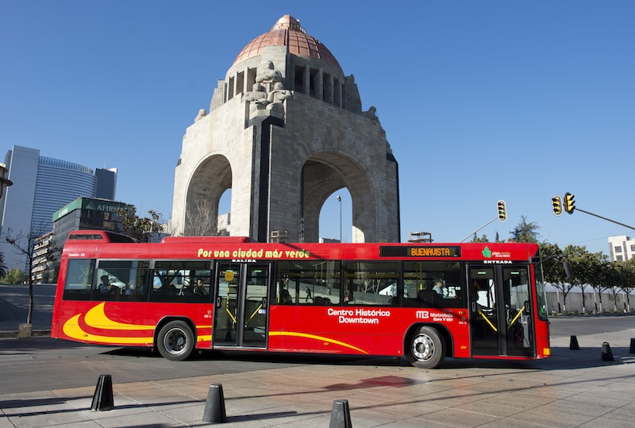

Image caption: Last year, Mexico City was awarded Mexico City the 2013 Sustainable Transport Award for its Bus Rapid Transit (BRT) system, cycling and walking infrastructure, parking program, and revitalization of public spaces.

Mexico City, Mexico implemented many projects in 2012 that have improved livability, mobility, and quality of life for its citizens, making the Mexican Capital a best practice for Latin America. The city expanded its BRT system, Metrobus, with Line 4, a corridor that extends from the historic center of the city to the airport. It also piloted a comprehensive on-street parking reform program (ecoParq), expanded its successful public bike system (Ecobici) and revitalized public spaces such as Alameda Central and Plaza Tlaxcoaque.

Past winners of the Sustainable Transport Award include: Medillin, Colombia and San Francisco, United States (2012); Guangzhou, China (2011); Ahmedabad, India (2010); New York City, USA (2009); London, UK (2008); Paris, France (2008); Guayaquil, Ecuador (2007); Seoul, South Korea (2006), and Bogotá, Colombia (2005).

